Siemens Healthineers Projects

1. Collision Avoidance System for Sliding CT

Project Overview
The Collision Avoidance System for Sliding CT was developed to enhance the safety and efficiency of the Nexaris Angio-CT Sliding System which is a system that integrates angiography and CT imaging in one suite, allowing seamless transitions without moving the patient.

Project Need
- Safety: Protects patients and staff from potential collisions with sliding gantry.
- Equipment Protection: Prevents damage to expensive medical machinery.
- Efficiency: Reduces downtime and improves overall workflow within the medical suite.

Project Solution

The solution involved developing a collision avoidance system using LIDAR sensors and Safety Designer Software for configuration. A workflow analysis and use case development were conducted to inform the system design. A rotating 3 degrees of freedom (DOF) mounting bracket for the sensor was designed using Siemens NX, enabling the system to detect and warn about potential obstacles. This ensures safer and more efficient operation of the Nexaris Angio-CT Sliding System.

Tools and Software Used
- SICK LIDAR Sensor
- Safety Designer Software
- Siemens NX for designing the sensor mounting bracket.
- MS Office for documentation
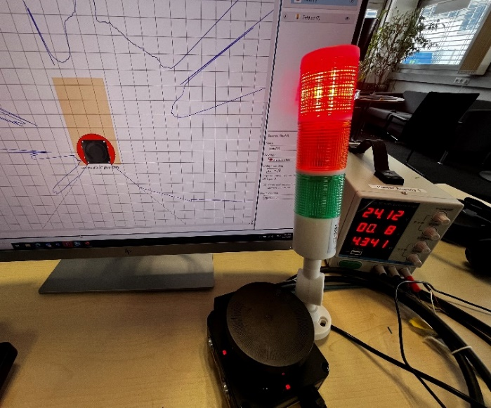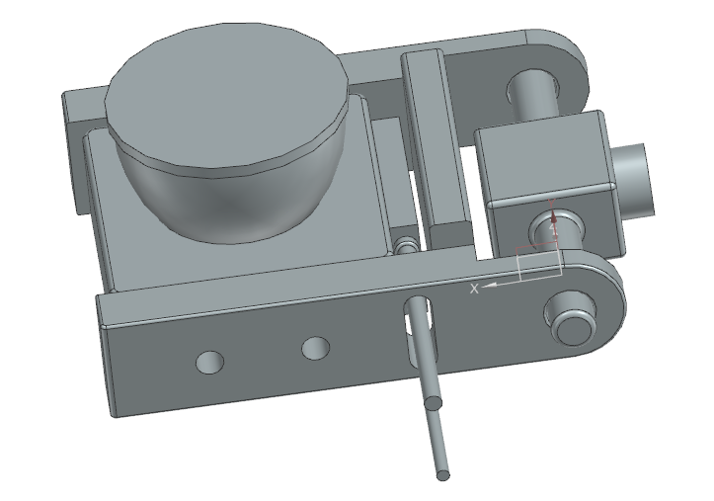

2. X-Ray Collimator Motion Detection

Project Overview
The X-Ray Collimator Motion Detection project aimed to improve the alignment accuracy of X-ray collimators, which is crucial for optimal imaging results.

Project Need
- Image Quality: Ensures accurate alignment of the X-ray collimator, reducing errors and improving image quality.
- Radiation Safety: Minimizes increased radiation exposure due to repeated manual adjustments.
- Operational Efficiency: Reduces the workload on radiologists and technicians by automating adjustments.

Project Solution
Implemented an orientation detection and Bluetooth connectivity system for X-ray collimators using the Bosch XDK and Eclipse Mita programming language. This solution helps in precisely detecting the collimator's position and transmitting the data wirelessly for real-time adjustments.

Tools and Software Used
- Bosch XDK for hardware and sensors.
- Eclipse Mita for software development and programming.
- BMI160 and BMM150 for orientation sensing.
- MS Office for documentation

